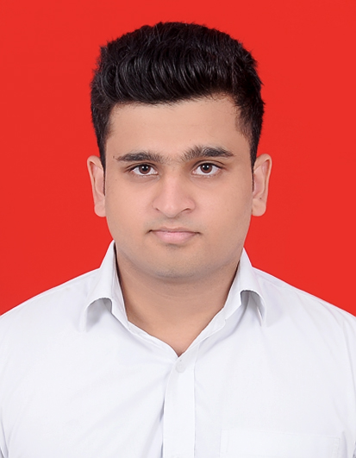
Dipanshu Sharma
Date Of Birth - 14-03-1994
Mobile - 8860953655
Email Id. - ds.dipanshu1994@gmail.com
Address - Q-1/3 Police Colony Andrews Ganj New Delhi - 110049

CAREER OBJECTIVE:-
To give my best in my professional pursuit for overall benefit and growth of the company that I serve by facing the challenges. I use my skills in the organization in such a way that it helps in organization’s growth as well as mine.

EDUCATION QUALIFICATION:-

- Pursuing Master in Computer Applications(M.C.A) from Management Education and Research Institute(M.E.R.I) (Guru Govind Singh Indraprastha University, New Delhi) with 75% Aggregate(Semester 1, Semester 2, Semester 3 and Semester 4 marks).
- Completed Bachelor in Computer applications (B.C.A.) from Kalka Institute for Research & Advanced Studies (Guru Gobind Singh Indraprastha University, New Delhi.) with 82.68% Aggregate
- Passed 12th from Delhi Police Public School, Safdarjung Enclave (C.B.S.E Board.)New Delhi in 2012 with 69.75% marks.
- Passed 10th from Delhi Police Public School, Safdarjung Enclave (C.B.S.E Board) New Delhi in 2010 with 6.6 CGPA.

WORK EXPERIENCE:-

- Worked as an Intern for 2 months in Simplion Technologies Inc. (Salesforce)

SKILLS:-

- Good Communication and Negotiation skills
- Cloud Computing platform – SALESFORCE
- Computer Languages like Java, JavaScript, Jquery, AngularJS, C#, Android, HTML, CSS, SQL
- Skills in text editors like SublimeText, Brackets, Atom, VS Code

HOBBIES:-

- Exercise to stay fit.
- Listening Music.
- Photography and Editing.

ACADEMIC PROJECT:-

- Project Name - Recruiting App
- Technology used – Cloud Computing
- Platform used – Salesforce

- Project Name – AstroGuru (URL: astromaster.co.in)
- Technology Used – ASP.net, HTML, JavaScript, CSS, Bootstrap
- Platform Used – Visual Studio

- Project Name – Next Steps Learning Centre
- Technology Used – Java
- Platform used – Eclipse Neon

- Project Name – Fit City
- Technology Used – Android
- Platform used – Android Studio

- Project Name – Gramin Sahayata
- Technology Used – Android
- Platform used – Android Studio

Achievements and Awards

- Represented at state(Delhi) level in cricket.
- Best Performance in Extra Curricular Activities in BCA
- Participated in National Seminar on Brain Based Learning with technological Support
- Participated in 15th National IT Seminar on Cyber Security,2015 at MERI
- Participated in National Seminar on Big Data and Cloud Computing
- Coordinator in Alumini Meet at MERI
- Coordinator in Annual Fest-La Kermesse
- Certificate of Participation in India Smart Grid Week Competition 2017
- Coordinator in Inter-College Competition – APPATHON, 2017 at MERI
- Won 2nd Prize in in Inter-College Competition – APPATHON, 2017 at MERI

DATE: ____________
PLACE: New Delhi DIPANSHU SHARMA

